### 

Risk Management Plan

Văn Lang Admissions

# Revision Table

|  |  |  |  |
| --- | --- | --- | --- |
| Author | Date | Reason for changes | Version |
| Minh Đoàn | 2/11/2016 | Initial Document | 1.0 |
| Minh Đoàn | 3/11/2016 | Fix Process and activities | 1.1 |
| 8/11/2016  10/11/2016 | Add legend board, input metrics for risk and risk list. |
| Minh Đoàn | 8/1/2017 | Fix Process and activities | 1.2 |
| Minh Đoàn | 9/2/2017 | Fix template | 2.0 |

Table of Contents

Revision Table 1

1. INTRODUCTION 3

1.1. Purpose 3

1.2. Audience 3

2. Process 4

2.1. Risk Development Process 4

2.2. Implement and Monitor Process 5

2.2.1. Review and Update Process 5

2.2.2. Prevent and Reduce Risk Process 6

2.3. Legends 6

2.4. Activities 7

3. Quantification 8

3.1. Risk Status 8

3.2. Risk Probability 8

3.3. Risk Severity 8

3.4. Risk Level 9

3.5. Risk Level Calculation 9

4. Roles and Responsibilities 10

5. Risk List 10

6. Risk Metrics 11

6.1. Goal-Question-Metric 11

6.2. Metric Definition 11

# INTRODUCTION

## Purpose

This document is description about Risk Management Plan. It introduces process flow of actions to manage risk in project, description of each action and measure risk.

## Audience

The main audiences of this document are: Mentor, Base Steps Solution Team.

# Process

## Risk Development Process



## Implement and Monitor Process

### Review and Update Process



### Prevent and Reduce Risk Process



## Legends

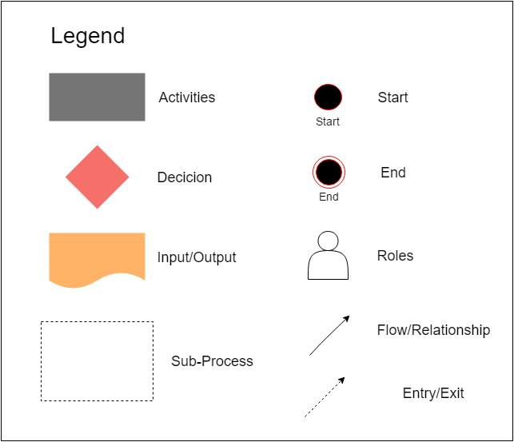

## Activities

|  |  |  |  |  |
| --- | --- | --- | --- | --- |
| Action | Description | Input | Output | Role |
| Identify Risk | Development team will define list of risk by:   * Brainstorming * Interview | Project scope, schedule, cost and constrain. | Risk List | Risk members |
| Analyze Risk | Analyze the several and probability of risk | Risk List | Risk Status | Risk members |
| Plan Action | Base on analysis of risk to find out the solution for risk and plan for implement that solution. | Risk List and Risk Status | Solution for Risk | Risk manager |
| Implement and Monitor | Execute action of solution for risk and document risk report | Solution for Risk | Risk Report | Risk members, Risk manager |
| Implement Reduce Impact Plan | Implement the solution to reduce the impact of risk when it happened | Solution for Risk | Risk Report | Risk Members |
| Implement Prevent Risk Plan | Implement the solution to prevent level of risk occurs | Solution for Risk | Risk Report | Risk Members |

# Quantification

## Risk Status

|  |  |
| --- | --- |
| Status of Risk | Description |
| Pending | Risk is proposed by Risk Member. |
| Rejected | Risk is rejected. |
| In Progress | Risk is being resolved to mitigate with solution by Risk Member. |
| Resolved | Risk is resolved and accepted by Risk Manager. |
| Not Resolved | Risk is outdated or turned into issues. |

## Risk Probability

|  |  |
| --- | --- |
| Ranking | Probability |
| Very High | 5 |
| High | 4 |
| Medium | 3 |
| Low | 2 |
| Very Low | 1 |

## Risk Severity

|  |  |
| --- | --- |
| Ranking | Impact |
| Critical | 5 |
| High | 4 |
| Medium | 3 |
| Low | 2 |
| Very low | 1 |

## Risk Level

|  |  |  |
| --- | --- | --- |
| Glossary | Description | Risk score = P*S |
| High | * Major disruption for BSS Team attention needed. * Immediate action required. | Risk score >= 15 |
| Medium | * Some disruption for BSS Team attention needed. * Managed by specific monitoring or response procedure. | Risk score >= 6  Risk score <= 12 |
| Low | Little or no disruption. | Risk score >=1  Risk score <= 5 |

## Risk Level Calculation

|  |  |  |  |  |  |
| --- | --- | --- | --- | --- | --- |
|  | **Risk Score = P*S** | | | | |
| 5 | 5 | 10 | 15 | 20 | 25 |
| 4 | 4 | 8 | 12 | 16 | 20 |
| 3 | 3 | 6 | 9 | 12 | 15 |
| 2 | 2 | 4 | 6 | 8 | 10 |
| 1 | 1 | 2 | 3 | 4 | 5 |
| **Probability**  **Severity** | 1 | 2 | 3 | 4 | 5 |

# Roles and Responsibilities

|  |  |  |
| --- | --- | --- |
| Role | Responsibilities | Assigned to |
| Risk Manager | * Review risk report * Monitor and control risk * Make acceptance for risk | Team Leader |
| Risk Member | * Define risks and give solution for each risk. * Support Risk Manager to implement and monitor risks. | BSS-Team |

# Risk List

BSS_RiskList_V1.0

# Risk Metrics

## Goal-Question-Metric

|  |  |  |
| --- | --- | --- |
| **Goal** | **Question** | **Metric** |
| Measure the level impact of risk | How do the risks impact to project? | **Risk Score = P * S**   * P: Probability of risk * S: Severity of risk |
| Check the increased level of risk after a month | How many risks increased after a month? | **NIR = NCR – NPR**   * NIR: Numbers of increased risks after a month. * NCR: Numbers of current risk. * NOR: Numbers of last month risk. |
| Check level of risk management | How many risks were solved? | **% solved risk = Solved Risks / Numbers of Risks** |

## Metric Definition

|  |  |  |  |  |  |  |
| --- | --- | --- | --- | --- | --- | --- |
| **ID** | **Name of metric** | **Formula** | **Goals** | **Collect procedure** | **Analyze procedure** | **Frequency** |
| 1 | Risk Score | Risk Score = P*S | Measure the level impact of risk | Be assessed by Risk members | * High: Risk score >= 15 * Medium: 12>=Risk score >=6 * Low: 5>=Risk score >=1 | * Collect: Monthly * Analysis: Monthly * Report: Monthly |
| 2 | NIR: Numbers of increased risks after a month. | NIR = NCR–NPR | Check the increased level of risk after a month | Be assessed by Risk members | * High: NIR > 1 * Medium: NIR = 1 * Low: NIR < 1 | * Collect: Monthly * Analysis: Monthly * Report: Monthly |
| 3 | Percent of solved risk | % solved risk = Solved Risks / Numbers of Risks | Check level of risk management | Be assessed by Risk members | * Very good: % solved risk < 80% * Good: 70% > % solved risk >= 20% * Bad: % solved risk < 20% | * Collect: Monthly * Analysis: Monthly * Report: Monthly |